
RAMAIAH
Institute of Technology
USN | 1 | M | S

(Autonomous Institute, Affiliated to VTU)
(Approved by AICTE, New Delhi & Govt. of Karnataka) Accredited by NBA & NAAC with ‘A’ Grade

SEMESTER END EXAMINATIONS – JUNE 2019

Course & Branch | : | B.E. : Common to all branches | Semester | : | II
Subject | : | Engineering Mathematics - II | Max. Marks | : | 100
Subject Code | : | MA21/MAT201 | Duration | : | 3 Hrs

Instructions to the Candidates:
- Answer one full question from each unit.

 |  | UNIT- I
1. | a) | State Taylor’s theorem for the function of two variables. | CO1 | (02)
 | b) | Show that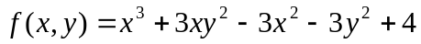 is minimum at the point (2, 0). | CO1 | (04)
 | c) | Find the radius of curvature of the curve 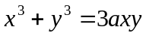 at the point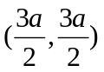. | CO1 | (07)
 | d) | A rectangular box open at the top is to have volume of 32 cubic feet. Find the dimensions of the box requiring least material for its construction. | CO1 | (07)
2. | a) | Define curvature and radius of curvature. | CO1 | (02)
 | b) | With the usual notation prove that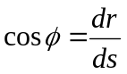. | CO1 | (04)
 | c) | If x, y, z are the angles of a triangle, find the maximum value of the cosx cosy cosz. | CO1 | (07)
 | d) | Obtain Taylor’s series expansion of log (cos) about the point 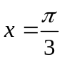 up to the fourth degree term. | CO1 | (07)
 |  | UNIT- II
3. | a) | Define an initial and boundary value problem. | CO2 | (02)
 | b) | Solve the differential equation 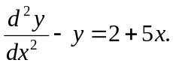 | CO2 | (04)
 | c) | The temperature of a cup of coffee is 92⁰ C, when freshly poured and the room temperature being 24⁰ C. In one minute it was cooled to 80⁰ C. How long a period must elapse, before the temperature of the cup becomes 65⁰ C? | CO2 | (07)
 | d) | Show that the family of curves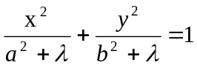 is  self-orthogonal, where is the parameter. | CO2 | (07)
4. | a) | If 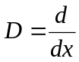and 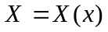, then prove that 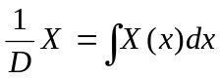. | CO2 | (02)
 | b) | The equation of an L-R circuit is given by 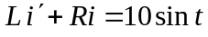 with 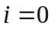at 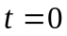. Express as a function of | CO2 | (04)
 | c) | Find the orthogonal trajectory for the family of curves 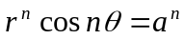, where is the parameter. | CO2 | (07)
 | d) | Solve the differential equation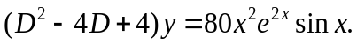 | CO2 | (07)
 |  | UNIT- III
5. | a) | Write a second order general Legendre’s linear differential equation. | CO3 | (02)
 | b) | Reduce 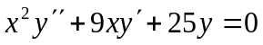into a linear differential equation with constant coefficients. | CO3 | (04)
 | c) | Solve 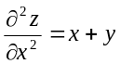 given that 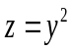 when 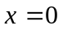 and 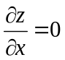when 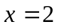 by direct integration. | CO3 | (07)
 | d) | Solve 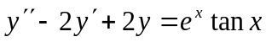 by the method of variation of parameters. | CO3 | (07)
6. | a) | Define partial differential equation and write one example. | CO3 | (02)
 | b) | Find the Wronskian of 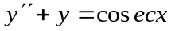. | CO3 | (04)
 | c) | Solve. | CO3 | (07)
 | d) | Solve 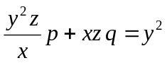by Lagrange’s method. | CO3 | (07)
 |  | UNIT- IV
7. | a) | Define the Dirac-Delta function. | CO4 | (02)
 | b) | Find 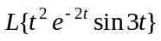. | CO4 | (04)
 | c) | Show that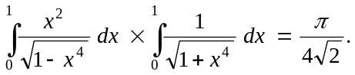 | CO4 | (07)
 | d) | Express 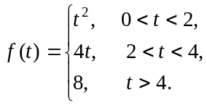in terms of the Heaviside function and hence find its Laplace transform | CO4 | (07)
8. | a) | Write the formula for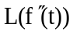 . | CO4 | (02)
 | b) | Evaluate 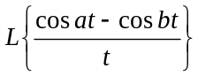 | CO4 | (04)
 | c) | (i) Find the Laplace transform of 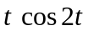  (ii) If 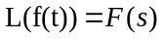 then prove that 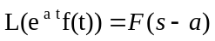 . | CO4 | (07)
 | d) | Obtain the relation between Beta and Gamma functions of the form 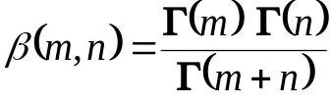. | CO4 | (07)
 |  | UNIT- V
9. | a) | State convolution theorem on Laplace transforms. | CO5 | (02)
 | b) | Find the Laplace transform of the triangular wave function of period , given by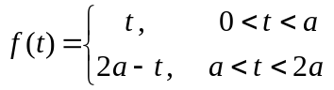. | CO5 | (04)
 | c) | Find inverse Laplace transform of the following i) and ii) 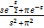. | CO5 | (07)
 | d) | Solve the differential equation 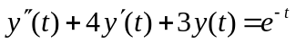,  Givenby using Laplace transform. | CO5 | (07)
10 | a) | Show that convolution of two functions is commutative. | CO5 | (02)
 | b) | A periodic function of period is defined by 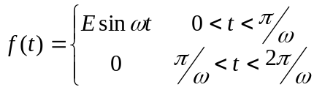, where and are positive constants, then show that . | CO5 | (04)
 | c) | Find the inverse Laplace transforms of i) and ii) . | CO5 | (07)
 | d) | The currents and in a mesh are given by the differential equations:  . Find the currents and by Laplace transforms if at . | CO5 | (07)

****************

